
SRM Institute of Science and Technology
College of Engineering and Technology
School of Computing
Department of Networking and Communications
Academic Year: 2023-24 (EVEN)
Test: CLA-T1 Date: 16.02.2024
Course Code & Title: 18CSC305J – Artificial Intelligence Duration: 50 minutes
Year & Sem: III Year / V Sem Max. Marks: 25

Answer Key

Q. No | Question
1 | AI Technique is a manner to organize and use the knowledge efficiently in such a way that _____.  - It should be perceivable by the people who provide it.  - It should be easily modifiable to correct errors.  - Both A and B  - None of the Above
2 | If “EAT + THAT = APPLE”, what is the sum of A+P+P+L+E?  - 13  - 14  - 12  - 16
3 | Which of the following is not the type of AI?  - Reactive machines  - Unlimited memory  - Theory of mind  - Self-awareness
4 | Which is used to improve the agents performance?  - Perceiving  - Learning  - Observing  - Training
5 | What is rational at any given time depends on?  - The performance measure that defines the criterion of success  - The agent’s prior knowledge of the environment  - The actions that the agent can perform  - All of the mentioned
6 | The Set of actions for a problem in a state space is formulated by a ___________  - Intermediate states  - Initial state  - Successor function, which takes current action and returns next immediate state  - Goal state
7 | The process of removing detail from a given state representation is called ______  - Extraction  - Abstraction  - Information Retrieval  - Mining of data
8 | Backtracking algorithm is implemented by constructing a tree of choices called as?  - State-space tree  - State-chart tree  - Node tree  - Backtracking tree
9 | In a constraint satisfaction problem, a constraint is:  - A solution to the problem  - A rule that limits the possible values of variables  - A variable that must be satisfied  - A function that evaluates the quality of a solution
10 | Which of the following is NOT a common approach to representing constraints in constraint satisfaction problems?  - Constraint networks  - Constraint satisfaction problems  - Constraint satisfaction languages  - Constraint satisfaction graphs
16 | Describe the types of agent with an example.  - Simple Reflex Agents  - Model-based Agents  - Goal-based agents  - Utility-based agents  - Learning agents  Explain each with example
17 | A person is in a house with switches for the light, fan, and TV, all initially in the OFF state. The person can only activate one switch at a time. The goal is to explore all potential sequences of switch activations leading to turning ON all three devices eventually. We need to construct a state space tree illustrating this scenario, identifying the initial state, final state, and total number of final states.  Initial state: [OFF, OFF, OFF]  Final state(s): [ON, ON, ON]  Total number of final states: 1  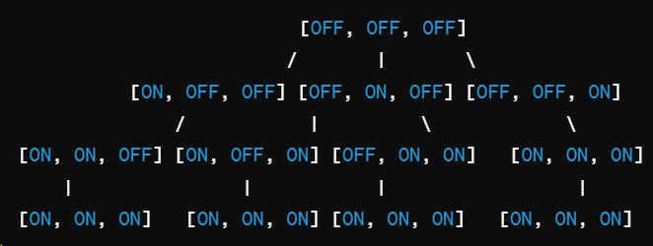
18 | We have five planes: A, B, C, D, and E and two runways: international and domestic. We would like to schedule a time slot and runway for each aircraft to either land or take off. We have four time slots: 1, 2, 3, 4 for each runway, during which we can schedule a landing or take off of a plane. We must find an assignment that meets the following constraints:  - Plane B has lost an engine and must land in time slot 1.  - Plane D can only arrive at the airport to land during or after time slot 3.  - Plane A is running low on fuel but can last until at most time slot 2.  - Plane D must land before plane C takes off, because some passengers must transfer from D to C.  - No two aircrafts can reserve the same time slot for the same runway.  Complete the formulation of this problem as a CSP in terms of variables, domains, and constraints (both unary and binary). Constraints should be expressed implicitly using mathematical or logical notation rather than with words.  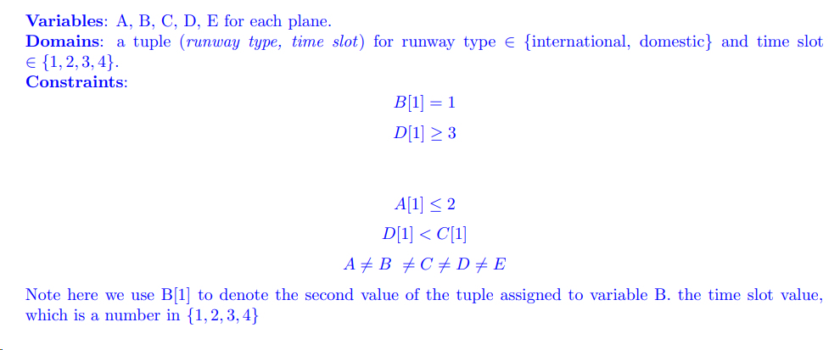  For the following parts, we add the following two constraints:  • Planes A, B, and C cater to international flights and can only use the international runway.  • Planes D and E cater to domestic flights and can only use the domestic runway.  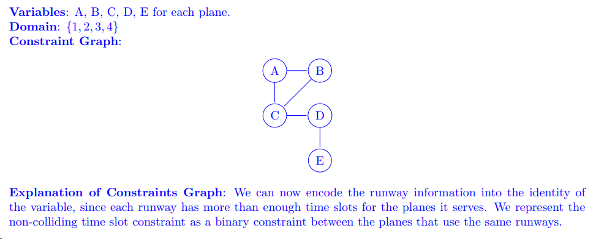
19 | Examine the PEAS descriptor for given environment  - Bidding on an item at an auction  Performance Measure: cost, value, necessity, quality  Environment: auctioneer, items, bidders  Actuators: speaker, display items  Sensors: camera, price monitor  - Knitting a sweater  Performance Measure: size, looking, comfort  Environment: craft, pattern  Actuators: needles, yarn, jointed-arms  Sensors: pattern sensor

